**Project Design Document**

**Mixed Reviews**

Naveen K

**High Level Architecture Diagram**

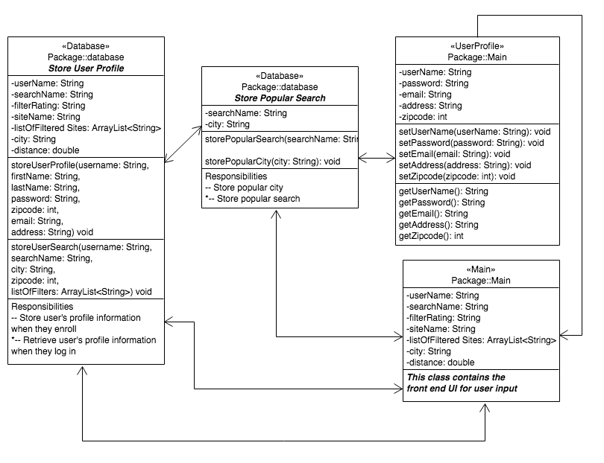

**High Level System Diagram**

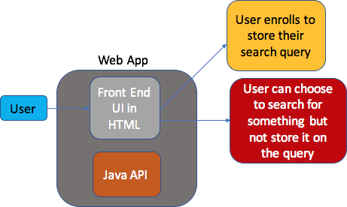

**Component Level Design**

* **Database Access Object:** This class will interface with the following tables for the database using JDBC:
  + userSearch, which will store the user’s information, and their search criteria, comprising of the search key, filter by rating, city, what sites to filter, city, and how far to look from the city. Note that in order for a user to save their search, they must enroll
  + generalSearch, which will store the general search history. The key difference is that this will not contain the user’s name because a user profile is required. Plus, the user will not be able to look at the general search criteria.
  + popularSearch, which will store the popular places to search. This will only store the most popular keywords for the search
  + popularCity, which will store the popular cities to eat or visit or do business in. This will not correlate with the popularSearch table.
* **Criteria**: This class will get the information on the search criteria, and pass it on to the database, and its appropriate relation. This will use basic getters and setters for OOP practices, as well as debugging purposes.
* **UserProfile**: This class will contain the information on the user’s profile, and pass it on to the database, and its appropriate relation. This will use basic getters and setters for OOP practices, as well as debugging purposes.
* **Main**: This will be the focal point of the program. The program will utilize the JavaFX UI to take in user input for searching. The user input Is done via a search bar. The user can also login to the program if they already have a user profile in the UserProfile database.

**Reusable Components**

* Database java class because this class is making all the queries as well as the connection to the database itself

UI Design

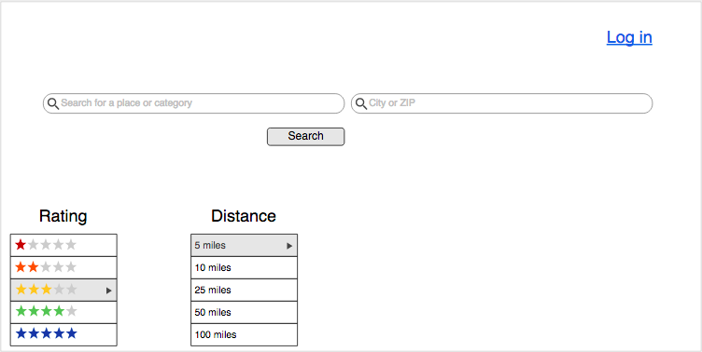

Java application

Note: There are only pre-defined categories if a particular search (not including location, filters, distance, or city), occurs more than a certain number of times. This becomes part of the popularSearch.

Class diagram

